SyncroPatch Automated Data Analysis User Manual
Heterozygous KCNH2 variant phenotyping using Flp-In HEK293 and high-throughput automated patch clamp electrophysiology
Contact: j.farr@victorchang.edu.au
Table of Contents
- Introduction
  - Onset of Inactivation
  - Steady-State Activation
  - Steady-State Deactivation Kinetics
  - Steady-State Deactivation Current Density Analysis sweep -50mV
  - Steady-State Deactivation Kinetics Density Analysis sweep -50mV/-120mV
- Analysis Pipeline
- Set-up
  - Code Requirements
  - Data Directory Structure
- Input Data Format Requirements
  - Quality Control File Structure
  - Onset of Inactivation Trace Data File Structure
  - Steady-State Activation File Structure
  - Steady-State Deactivation File Structure
  - Variant .txt file
- Output Directory and Results File Structure
- Run Quality Control Script
  - QC function input Parameters
- Run High-throughput Automated Data Analysis Scripts
  - Analysis script input Parameters
- Example Workflow

- Introduction
This user manual outlines how to use the python scripts created for the automated data analysis of the electrophysiological dataset obtained from the Nanion Technologies SyncroPatch automated patch clamping device. Script have been implemented to allow the full automated data analysis for steady-state deactivation kinetics and current density assays, onset of inactivation kinetics and steady-state activation kinetics assays. The scripts can be found at

https://git.victorchang.edu.au/projects/SADA

  - Onset of Inactivation
The analysis of the onset of inactivation protocol filters out the sweeps in the QC phase based on the seal, capacitance, series resistance, peak current and leak current amplitudes. The onset leak check checks the amplitude of the leak current is within the range -100E-12A<=leak_current<=100E-12A. All other QC parameters are input options. The filtered data is then fed into the high-throughput analysis script where it will fit each of the current traces produced by the sweep’s voltage stimulus with a single exponential model using linear regression. The script will display plots of the trace data with their models overlaid as .png files in the plot directory of choice. The script will also produce csv results files summarising the model parameters and their confidence intervals as well as any warnings. The script detects if the tau value is too long and if the model is accurate. It also executes post analysis quality control by fitting the tau values to an exponential model (if there is enough data to do so). Further warnings are generated if the postQC tau fit is poor. The script produces plots of the postQC tau fits if they were generated. The script also produces a summary csv file for sweep that was input by the user of the tau values from the wells that possessed good results.

  - Steady-State Activation
The analysis of the steady state activation protocol involves the seal, capacitance, series and leak current amplitude checks. The leak current range for this was -40E-12A<=leak_current<=40E-12A. All other threshold parameters are entered as inputs from user. The filtered data is then fed into the high throughput analysis script which calculates the current density for each sweep by dividing the peak current by the capacitance. It then normalises this between 0 and 1 and fits the normalised CD data with a Boltzmann model to obtain the V0.5 activation among other data characteristics. The script output plots of the Boltzmann models overlaid on the normalised current densities per sweep and also and csv file for each well summarising the current density and model parameters for V0.5 and thermal Boltzmann models. These csv files also contain warnings about questionable data characteristics that were observed in the analysis like plateau not reached, model midpoint not aligning with data midpoint and endogenous experimental current observed. The script also produces summary statistics for the summary sweep that was input for the current densities for each well that had good results and produces a summary csv for the V0.5, k, z, and G0 parameters.

  - Steady-State Deactivation Kinetics
All steady state deactivation protocols use the same QC analysis. The QC analyses the seal, capacitance, series resistance and -40E-12A<= leak current<=40E-12A. The filtered files are then fed into the high throughput analysis scripts that will fit the successful QC sweeps with double exponentials. The script then produces plots of these trace recordings and their fits and then summarises the fit parameters in csvs for each well. It also will attach warnings for each sweep if the amplitudes are outside the possible range, if the tau values are not logical, if the peak current is too low for the summary sweep and if the model fit was poor. It also calculates a tau weighted value and fits these per their sweep voltage to an exponential model and ensures the trend of tau weighted values per sweep exhibit an exponential trend as expected. Png plots of these are produced if they are available. The script also produces a summary csv file of the tau weighted values for the wells that exhibited good data for the summary sweep of interest.

  - Steady-State Deactivation Current Density Analysis sweep -50mV
Input QC modified files into the script. The user must input the peak current threshold for the sweep at -50mV. The script then produces a csv file depicting the current densities for each well (current density = peak current/capacitance). Also produces plots of the traces with relevant peaks annotated.
  - Steady-State Deactivation Current Density Analysis sweep -50mV, ratio of peaks at 250/500ms
Input QC modified files into the script. The user must input the peak current threshold for -50mV. The script then produces two csv file depicting the ratios of the current at 250ms/peak and a csv with the currents at 500ms/peak for each sweep that exhibited high enough amplitudes. Also produces plots of the traces with relevant peaks annotated.

1.6 Steady-State Deactivation Kinetics Density Analysis sweep -50mV/-120mV
Input QC modified files into the script. The user must input the peak current threshold for -50mV and -120mV. The script then produces a csv file depicting the ratios of the peak of -50mV/peak of -120mV for each variant. Also produces plots of traces with relevant peaks annotated.

- Analysis Pipeline

The scripts are designed in a way such that there is a ‘filtration’ phase in which the quality control data is analysed and datasets that failed any quality control parameters will be excluded from downstream analyses. The pertinent quality control parameters being seal resistance, series resistance, cell capacitance, max/min current density and the magnitude of the leak current. The filtered data is then input into the high-throughput analysis scripts, which analyses the sweeps of the successful QC data. Each script has inbuilt post-quality control functions that further filter the results depending on the characteristics of the data and attempts to identify and separate experimentally unfavourable datasets from the analysis. The script has variable outputs depending on the experimental protocol being used, however generally it produces .png files of the plots of the trace data with the kinetic model overlaid and produces a results directory that stores the model fit parameters and any warnings that were detected during the analysis in a csv file for each well. Each well’s results are sorted into a folder named after the genetic variant that was plated in that well.
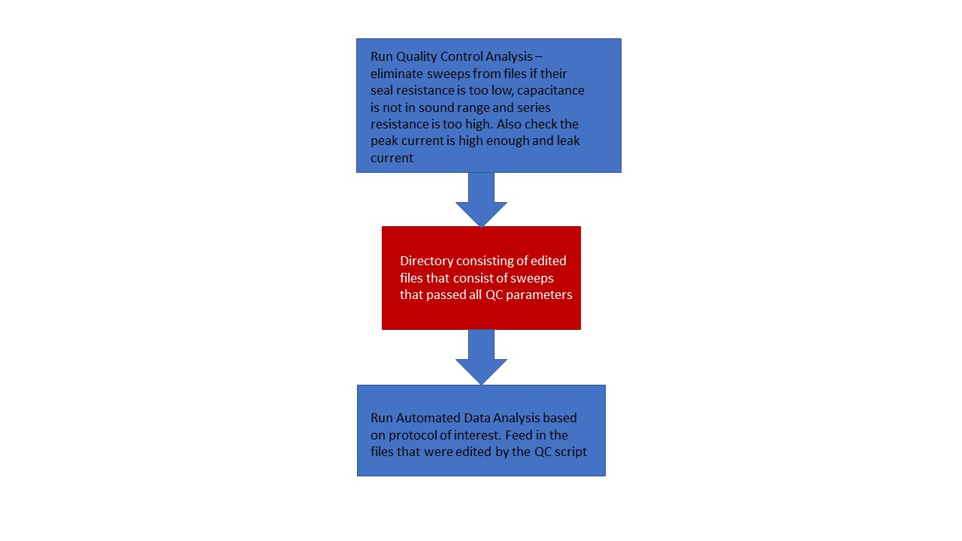

- Set-up
  - Code Requirements
The data analysis scripts require the use of python 3.8
To install the correct python modules run the command to install the module requirements found in the requirements.txt file:
“Py -m pip install -r requirements.txt”
  - Data Directory Structure
Input Data should be stored in a directory structure similar to the following:
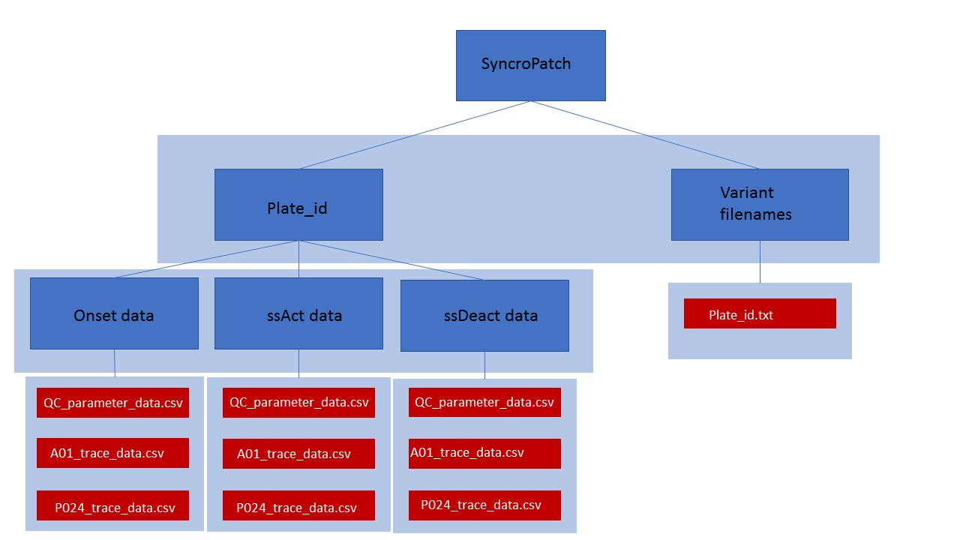

- Input Data Format Requirements

Each of the input data files (trace recording data for each well and the QC file for the plate) for each experimental protocol must be stored as a csv file.

  - Quality Control File Structure
- Semi-colon delimited
- Row 1 = Sweep Headers (‘Sweep Results’ ‘Sweep001’ ‘Sweep001’ ‘Sweep001 ‘Sweep002’ ‘Sweep002’ ‘Sweep002’ …)
- Row 2 = QC Parameter Headers (‘Parameter’ ‘Valid QC’ ‘Seal Resistance’ ‘Capacitance’ ‘Series Resistance’)
- Row 3 = Time of Sweep
- Row 4…end = QC parameters for each well
- Column 1 = wellID (A01-P24) - start at row 4
- Column 2 = ValidQC (T/F)
- Column 3…3…end-2 = Seal Resistance for sweep for each well
- Column 4…3…end-1 = Capacitance for sweep for each well
- Column 5…3…end = Series Resistance for sweep for each well
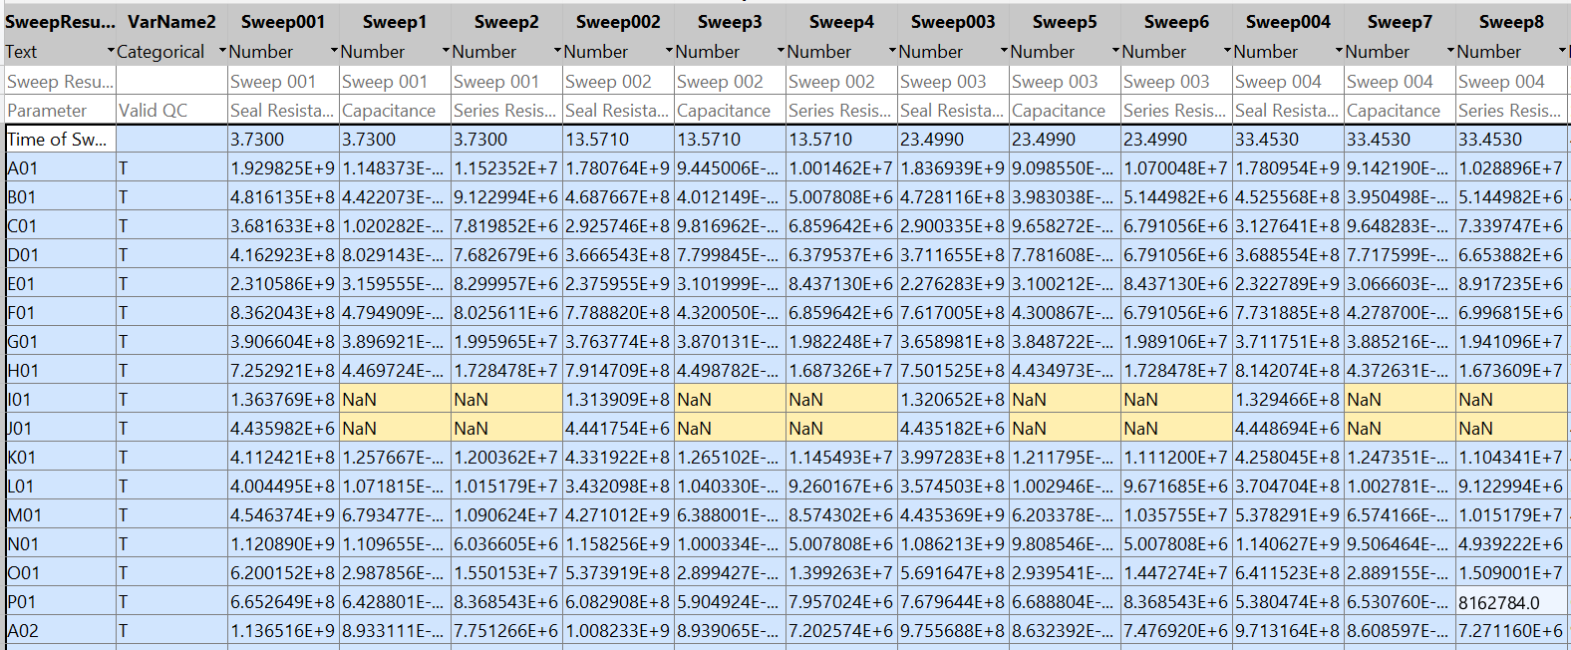
- NOTE: the QC parameters must be stored in that column order (seal, capacitance, series). This is a key input requirement of the QC script.

  - Onset of Inactivation Trace Data File Structure
- Tab delimited
- Row 1 = Sweep Count followed by 1..n where n is the number of sweeps for the experiment
- Row 2 = Sweep Time followed by the time each sweep was initiated in the experiment. Stimulus columns left bare
- Row 3 = Headers (‘Sample Point’ ‘Sample Time (us)’ ‘Stimulus’ ‘Raw Data (A)’…)
- Row 4…end = Raw data.
- Column 1 = Sample Point (1…n where n is the number of data recording samples)
- Column 2 = Time in microseconds
- Column 3..2…end-1 = Sweep 1 voltage stimulus in millivolts
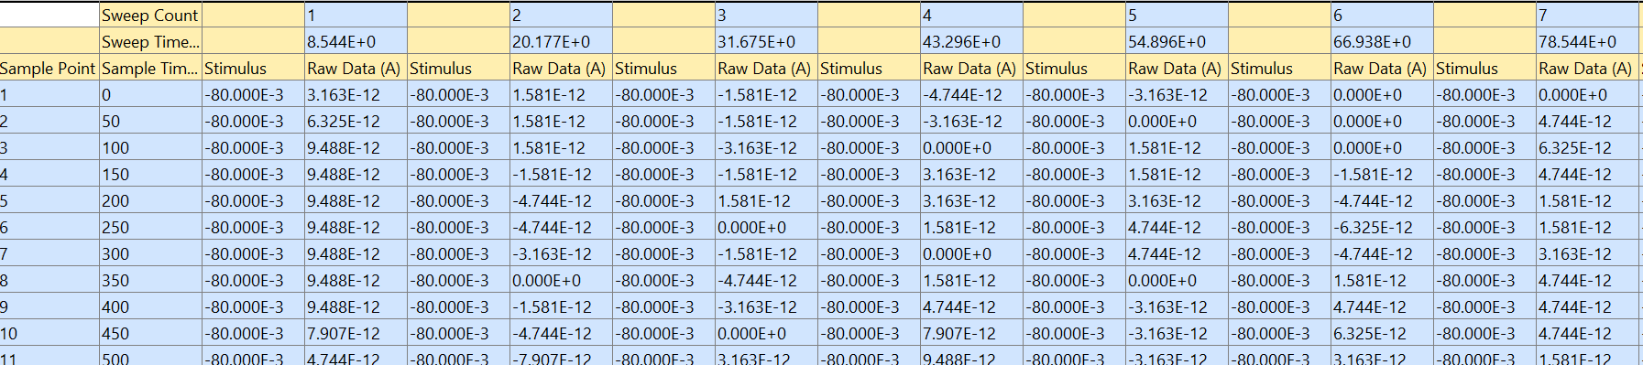
- Column 4..2…end = Sweep 1 current data in amperes

  - Steady-State Activation File Structure
- Tab delimited
- Row 1 = Sweep Count followed by 1..n where n is the number of sweeps for the experiment
- Row 2 = Sweep Voltage. The stimulus voltage used for that sweep in (mV). Keep the Stimulus columns empty.
- Row 3 = Headers (‘Sample Point’ ‘Sample Time (us)’ ‘Stimulus’ ‘Raw Data (A)’…)
- Row 4…end = Raw data.
- Column 1 = Sample Point (1…n where n is the number of data recording samples)
- Column 2 = Time in microseconds
- Column 3..end-1 = Sweep 1 voltage stimulus in millivolts
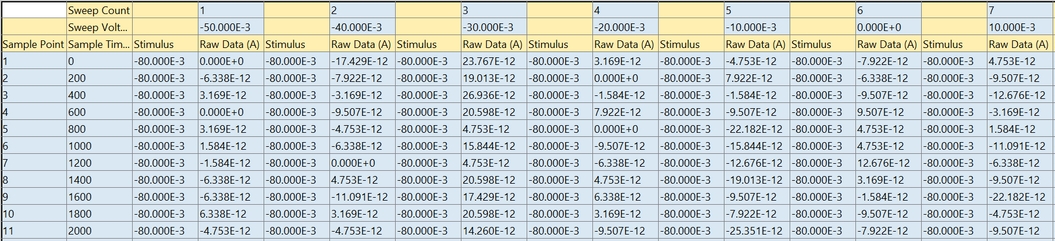
- Column 4..end = Sweep 1 current data in amperes

  - Steady-State Deactivation File Structure
- Tab delimited
- Row 1 = Sweep Count followed by 1..n where n is the number of sweeps for the experiment
- Row 2 = Sweep Voltage. The stimulus voltage used for that sweep in (mV). Keep the Stimulus columns empty.
- Row 3 = Headers (‘Sample Point’ ‘Sample Time (us)’ ‘Stimulus’ ‘Raw Data (A)’…)
- Row 4…end = Raw data.
- Column 1 = Sample Point (1…n where n is the number of data recording samples)
- Column 2 = Time in microseconds
- Column 3..end-1 = Sweep 1 voltage stimulus in millivolts
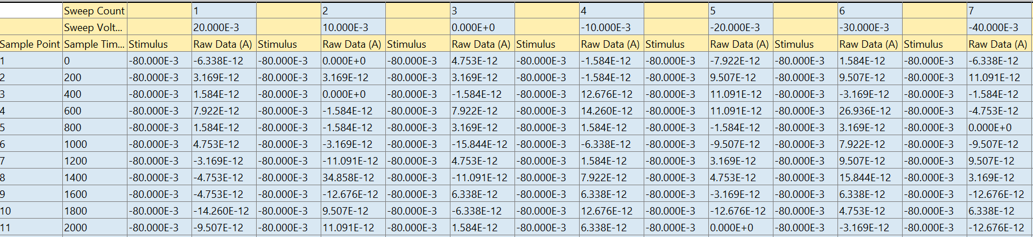

  - Variant .txt file
- .txt file that stores each of the variants used in the experiment
- It is assumed the variants are plated on the columns of the SyncroPatch plate
- It is assumed that the variants take up 2 columns
- The order the variants are entered in the .txt file corresponds to the order the variant was plated i.e. first variant in list for well from columns (A01:P01 and A02:P02).
- Each variant is entered on a new line.
- Assumed to be 12 variants per file.
- Output Directory and Results File Structure
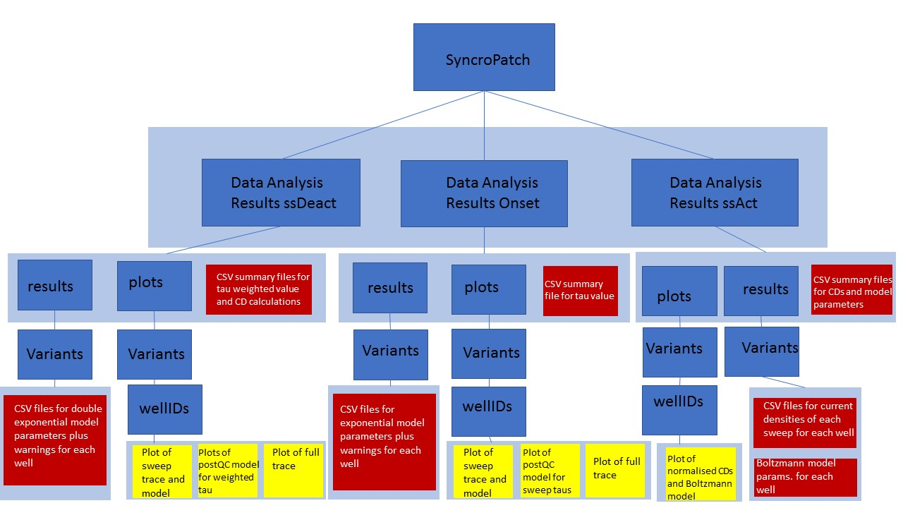

- Run Quality Control Script
  - QC function input Parameters
Go into the quality_control_sat_mut_py.py script and find the main() function on line 434. Inside this, uncomment (delete the # character in front of the line of code that looks like the following) and enter your inputs as pertinent to the following input parameter descriptions. To run the code using pycharm right click the window containing the code and select ‘Run’. Run via command line by entering “py quality_control_sat_mu_py.m”. Enter QC input prompts as required.
quality_control_sat_mut_py(parent dir, data dir, plate name, QC file name, variant file path, num sweeps, protocol)

    - Parent directory
The path to the directory that stores the data_dir and variant file path. Use os.path.join() and string notation to input directories in the path.
    - Data directory
The name of/path to the directory inside parent_dir that stores the current trace data and the QC parameter file name. Use os.path.join() and string notation to input directories in the path.
    - Plate name
The plate_id of the plate currently being analysed. Used to name the output directory that stores the results of this plate’s protocol analysis. String input.
    - QC file name
The name of the csv file that contains the QC parameter data for the plate. String input. Requires .csv file identifier.
    - Variant file name path
The path to the variant .txt filename that stores the names of the variants used in each of the 24 columns of the plate. Base from the parent_dir input. . Use os.path.join() and string notation to input directories in the path. Requires .txt file identifier for file name.
    - Number of sweeps in protocol
Integer representing the number of sweeps used in the protocol i.e. ssDeact uses 18, ssAct uses 13 and onset uses 12. Integer input.
    - Protocol
String denoting the type of protocol analysis that is required by the data set. Must enter exactly as seen here. For onset of inactivation assays enter ‘Onset’. For steady state activation assays enter ‘ssAct’. For steady state deactivation assays enter ‘ssDeact’.

- Run High-throughput Automated Data Analysis Scripts
  - Analysis script input Parameters
Go into the high_throughput_sat_mut_python.py script and find the main() function on line 652. Inside this, uncomment (delete the # character in front of the line of code that looks like the following) and enter your inputs as pertinent to the following input parameter descriptions. To run the code using pycharm right click the window containing the code and select ‘Run’. Run via command line by entering “py high_throughput_sat_mu_python.m”. Enter input prompts as required.
high_throughput(parent dir, plate name, QC dir, fit RSquared threshold, variant filename path, summary sweep voltage, number of sweeps, protocol)

    - Parent directory
The path to the directory that stores the data_dir and variant file path. Use os.path.join() and string notation to input directories in the path.
    - Plate name
The plate_id of the plate currently being analysed. Used to name the output directory that stores the results of this plate’s protocol analysis. String input.
    - Successful QC results directory
The name of the directory that was entered by the user when the QC script prompted for the name of the directory that stores the data that passed QC requirements. String input.
    - R-Squared threshold
Floating point value between 0 and 1 that will be used as the threshold to identify good model fits. 0.85 recommended for ssDeact. 0.99 recommended for onset, 0.85 recommended for ssAct.
    - Variant file name path
The path to the variant .txt filename that stores the names of the variants used in each of the 24 columns of the plate. Base from the parent_dir input. Use os.path.join() and string notation to input directories in the path. Requires .txt file identifier for file name.
    - Summary voltage sweep
Integer representing the voltage of the sweep that will be summarised in the summary file output. ssDeact Fit summary files contain tau_weighted for each variant. ssDeact CD summary contains the current density ratios for each variant. Onset contains tau for each variant. ssAct contains summaries for current densities and also Boltzmann V05 and thermals model parameters.
    - Total number of sweeps
Integer representing the number of sweeps used in the protocol i.e. ssDeact uses 18, ssAct uses 13 and onset uses 12. Integer input
    - Protocol
String denoting the type of protocol analysis that is required by the data set. Must enter exactly as seen here. For onset of inactivation assays enter ‘Onset’. For steady state activation assays enter ‘ssAct’. For steady state deactivation kinetics assays enter ‘ssDeact Fit’. For steady state deactivation current density assays analysing peak at 250ms/peak enter ‘ssDeact CD -50 250/500’. For steady state deactivation current density assays analysing peak at -50/peak at -120 enter ‘ssDeact CD -50/-120’ and for the raw current density calculations for sweep -50 enter ‘ssDeact CD -50’.

- Example Workflow
Please download the example dataset found at:

https://doi.org/10.26190/7tqy-gc11

Once the dataset is downloaded you should have a directory that is structured as such:

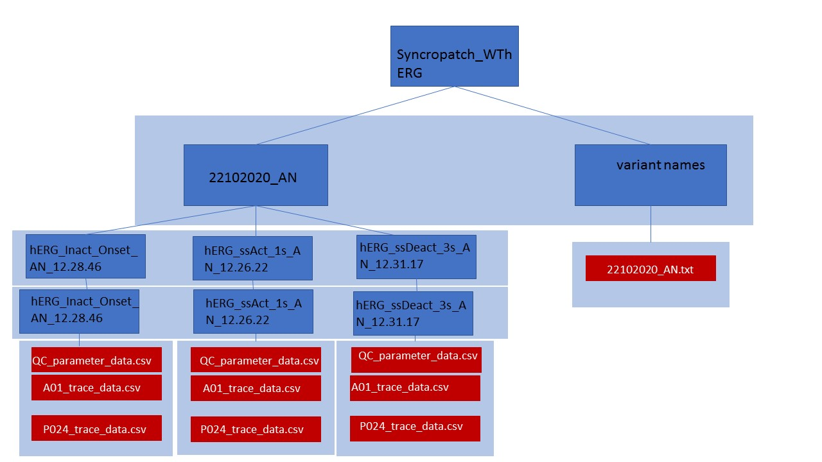

First run the quality control analysis for each protocol by entering the following lines of code on line 434 in main() in quality_control_sat_mut_py.py. Enter the input prompts for each protocol as requested by the command line. Please note the use of os.path.join() for directory path inputs. The parent_dir input includes the input ‘Z://’ which should be used if data is stored in a different drive to where the analysis code is stored i.e. in this case the data was stored in the Z drive and hence requires the first input to be ‘Z://’.

quality_control_sat_mut_py(os.path.join('Z://', 'Syncropatch_WThERG'), os.path.join('22102020_AN', 'hERG_Inact_Onset_AN_12.28.46', 'hERG_Inact_Onset_AN_12.28.46'), '22102020_AN', 'parameters_22102020_AN_hERG_Inact_Onset_AN_12.28.46.csv', os.path.join('variant names', '22102020_AN.txt'), 12, 'Onset')
quality_control_sat_mut_py(os.path.join('Z://', 'Syncropatch_WThERG'), os.path.join('22102020_AN', 'hERG_ssAct_1s_AN_12.26.22', 'hERG_ssAct_1s_AN_12.26.22'), '22102020_AN', 'parameters_22102020_AN_hERG_ssAct_1s_AN_12.26.22.csv', os.path.join('variant names', '22102020_AN.txt'), 13, 'ssAct')
quality_control_sat_mut_py(os.path.join('Z://', 'Syncropatch_WThERG'), os.path.join('22102020_AN', 'hERG_ssDeact_3s_AN_12.31.17', 'hERG_ssDeact_3s_AN_12.31.17'), '22102020_AN', 'parameters_22102020_AN_hERG_ssDeact_3s_AN_12.31.17.csv', os.path.join('variant names', '22102020_AN.txt'), 18, 'ssDeact Fit')

Once the quality control has been complete then run the following lines of code in the high_throughput_sat_mut_python.py script to run each protocol. It is assumed the user input ‘success_QC’ for the name of the directory that stores the successful QC dataset. Go to line 652 and edit the inputs for the high_throughput() function as required. Note the use of os.path.join() to enter directory inputs.

high_throughput(os.path.join('Z://', 'Syncropatch_WThERG'), '22102020_AN', 'success_QC', 0.85, os.path.join('variant names', '22102020_AN.txt'), -50, 18, 'ssDeact Fit')
high_throughput(os.path.join('Z://', 'Syncropatch_WThERG'), '22102020_AN', 'success_QC', 0.85, os.path.join('variant names', '22102020_AN.txt'), -50, 18, 'ssDeact CD -50')
high_throughput(os.path.join('Z://', 'Syncropatch_WThERG'), '22102020_AN', 'success_QC', 0.85, os.path.join('variant names', '22102020_AN.txt'), -50, 18, 'ssDeact CD -50/-120')
high_throughput(os.path.join('Z://', 'Syncropatch_WThERG'), '22102020_AN', 'success_QC', 0.99, os.path.join('variant names', '22102020_AN.txt'), 0, 12, 'Onset')
high_throughput(os.path.join('Z://', 'Syncropatch_WThERG'), '22102020_AN', 'success_QC', 0.85, os.path.join('variant names', '22102020_AN.txt'), 40, 13, 'ssAct')

